EXPERIMENT 1
ROLL NO:240702380 NAME: PAVITHRA B

USER INTERFACE AND DESIGN

COMPARISON OF UI BETWEEN TWO FIGMA CREATION

BAD WEBSITE

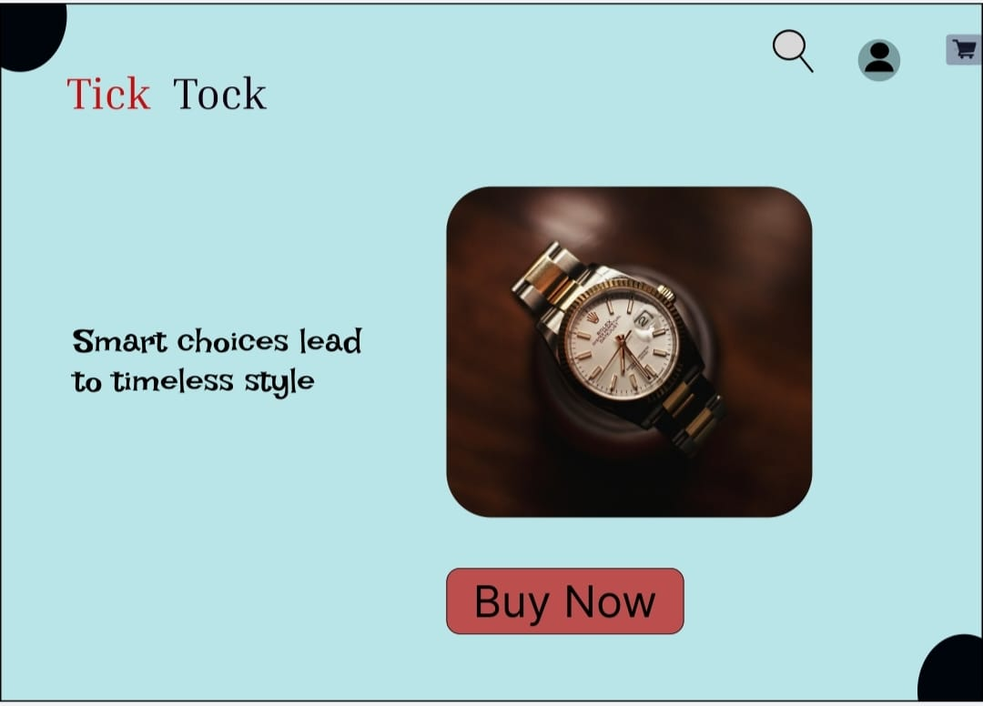

GOOD DESIGN
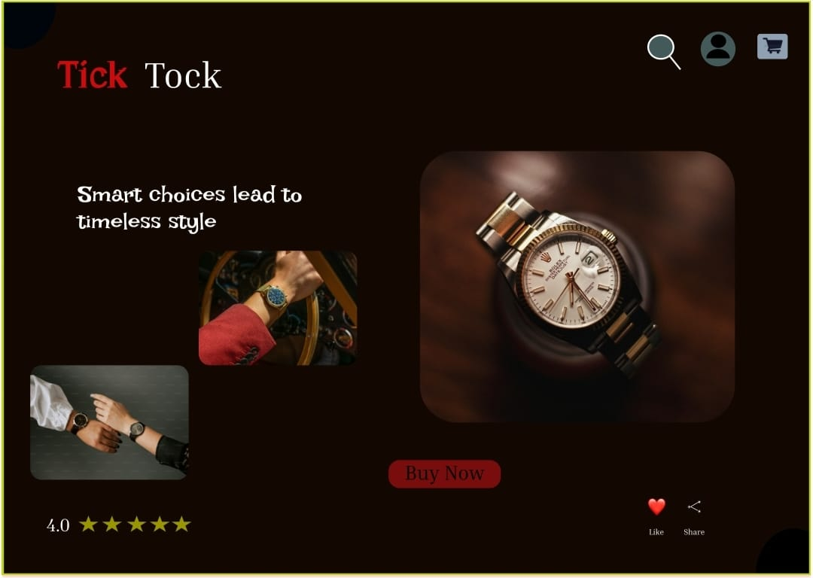

PROTOTYPE LINK:-
https://www.figma.com/proto/9W3faeMWuwcWay4Nb5JNYI/Untitled?node-id=63-17&t=2ABWBUZ2NNIlOzCn-1

https://www.figma.com/proto/9W3faeMWuwcWay4Nb5JNYI/Untitled?node-id=65-22&t=2ABWBUZ2NNIlOzCn-1

BAD WEBSITE (Tick Tock – Desktop)

- Design Style:
Very simple and plain layout
Large empty spaces with poor alignment
Looks unfinished and less attractive
- Content:
Shows only the watch image and brand name
No description or supporting text
Content does not explain why the product is special
- Navigation:
Only a single “Buy Now” button is present
No menu or clear navigation options
User may feel confused about next steps
- Purpose:
Purpose is not clearly communicated
Does not strongly encourage users to explore or purchase
Poor user engagement

GOOD WEBSITE (Tick Tock – Desktop)

- Design Style:
Clean and modern layout
Proper spacing and alignment
Uses dark colour background to create a premium and attractive look
Balanced colours make the product stand out clearly

- Content:
Clear brand name with a meaningful tagline
Large and focused product image
Displays ratings (stars) to show product quality
Content feels complete and informative
- Navigation:
Clear layout guides the user naturally
“Buy Now” button is well placed and noticeable
Share and Like options are included for user interaction
Easy for users to understand what action to take
- Purpose:
Clearly designed for product promotion
Dark colour theme increases visual attraction and user focus
Ratings and share options build trust and engagement
Encourages users to purchase the watch
Creates a professional and trustworthy impression

Key Differences:
Focus: Bad design lacks clarity, while good design highlights the product effectively
Design Aesthetics: Bad design is plain; good design is polished with an attractive dark theme
Content Depth: Good design provides better visual communication with ratings and actions
User Experience: Good design is easy to use, engaging, and interactive

